Ceachi Bogdan- gr.406

Proiect Securitatea Bazelor de date

Agentie de Turism

# 1.Introducere

## a) Modelul proiectat și regulile sale

In acest proiect prezentam modelul bazei de date al unei agentii de turism. Organizarea activitatilor turistice se realizeaza de catre diversi agenti de turism(persoane fizice care presteaza servicii specifice), iar agentia de turism este intermediarul privilegiat intre acesti prestatori si turist. Activitatile firmei, consta in producerea si promovarea de aranjamente turistice diverse.

In functie de departament, fiecare angajat dispune de un anumit rol, angajatii trebuie sa ponteze zilnic la finalul zilei lucratoare si sa aibe posibilitatea sa poata realiza o cerere de concediu. De asemenea, fiecare angajat va fii inregistrat in baza de date si se vor putea authentifica pe baza emailului si parolei, credentialele vor fii criptate cu chei diferite.

## b) Diagramele bazei de date

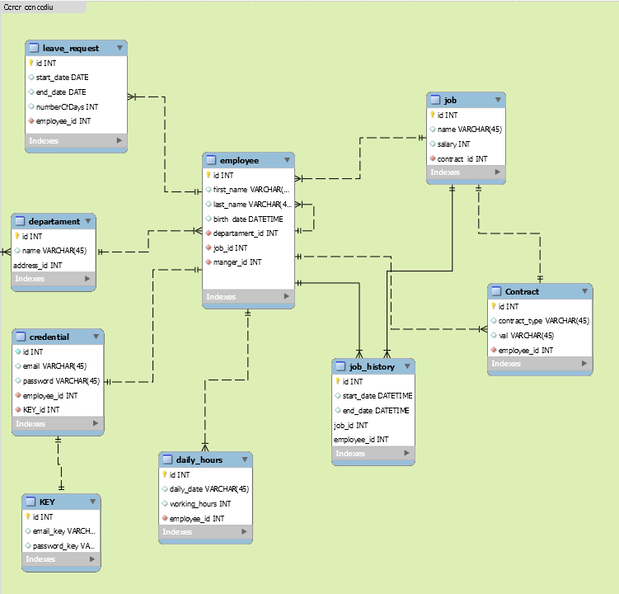

## c) Schemele relaționale

**EMPLOYEE**(#ID,FIRST_NAME, LAST_NAME, BIRTH_DATE, DEPARTMENT_ID, JOB_ID, MANAGER_ID);

**JOB(**#ID, NAME, SALARY);

**CONTRACT(**#ID, CONTRACT_TYPE, VAL, EMPLOYEE_ID);

**JOB_HISTORY**(#ID, START_DATE, END_DATE, JOB_ID, EMPLOYEE_ID);

**DAILY_HOURS**(#ID, DAILY_DATE, WORKING_HOURS, EMPLOYEE_ID);

**KEY**(#ID, EMAIL_KEY, PASSWORD_KEY);

**CREDENTIAL(**#ID, EMAIL_KEY, PASSWORD_KEY);

**DEPARTAMENT(**#ID, NAME, ADDRESS_ID);

**LEAVE_REQUEST(**#ID, START_DATE, END_DATE, NUMBEROFDAYS, EMPLOYE_ID);

## d) Crearea tabelelor



2.Criptarea datelor



# 3. Auditarea activităților asupra bazei de date

## a. Auditare standard

- se realizarea asupra bazei de date atunci cand se doreste adaugarea sau stergerea unui employee.

Deschidem sql plus si ne logam ca si sys:

User-name : sys as sysdba

Password: admin

* show parameter audit_trail

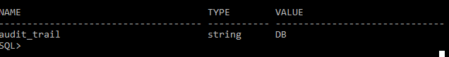

* show parameter audit_file_dest
* alter system set audit_trail = DB, EXTENDED scope=spfile;
* shutdown immediate
* am intampinat urmatoarea eroare:

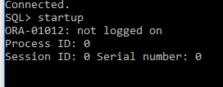

Pentru a rezolva aceasta problema: intram in Task-Manager-> Startup si restartam procesele SQL

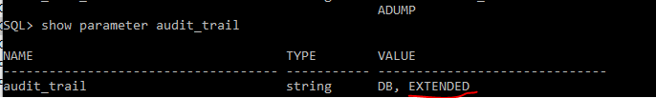

* audit table;
* audit select,update,delete on c##agency_administrator.EMPLOYEE by access;
* desc dba_audit_trail

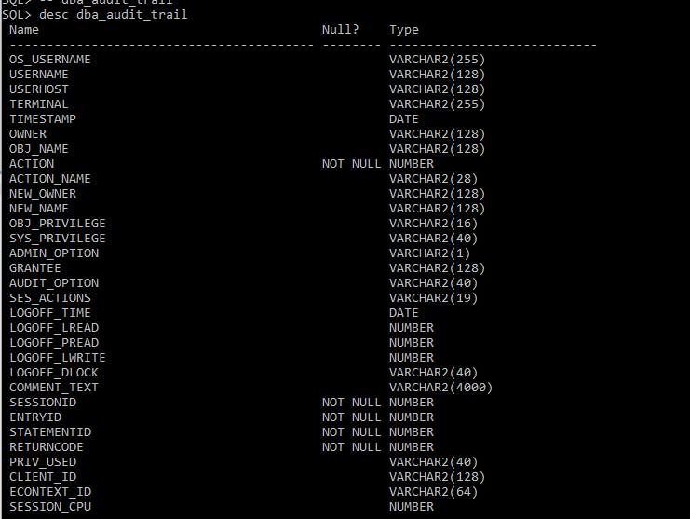

* col sql_text format a50
* col username format a12
* col owner format a10
* set lin 200
* set pagesize 200
* select os_username, username, owner, timestamp, action, sql_text from dba_audit_trail;



* **ne connectam in sql plus cu c##agency_administrator**
* set lin 100
* set pagesize 100
* select id, first**_**name, last_name from employee;

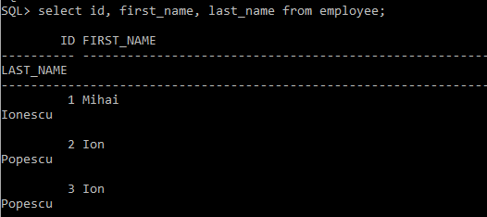

* ne intoarcem in sql plus ca sys:

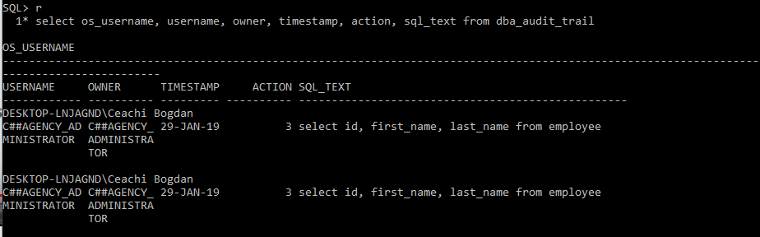

* ne conectam in sql plus cu userul : c##agency_administrator
* update employee set first_name = ‘testare_audit’ where id = 1;

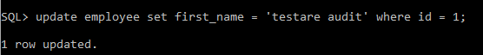

* **revenim ca sys si ne uitam in audit**

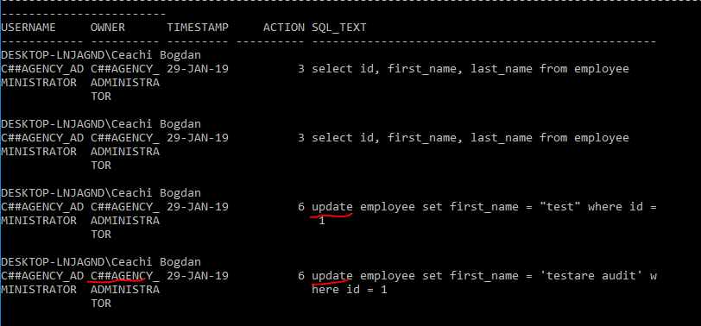

* 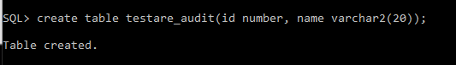
* 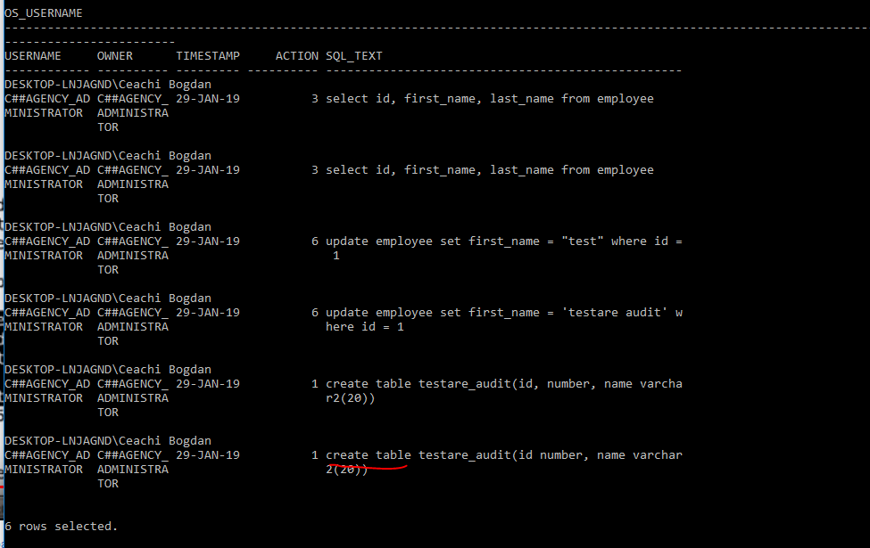
* audit table by c##agency_administrator whenever not successful;

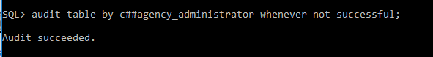

* 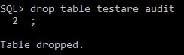
* **Acum inchidem auditarea:**
* alter system set audit_trail = DB scope=spfile;

**t**

* shutdown immediate
* startup

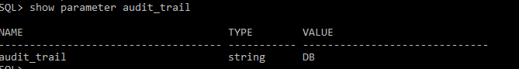

## b. *Trigger*-i de auditare

Dorim sa retinem orice modificare efectuata asupra tabelei Job, atunci cand se doreste modificarea salariului. In aceasta tabela se vor memora vechiul dar si noul salariu inainte sa modifica inregistrarea din tabela. Pentru fiecare modificare se stocheaza utilizatorul si momentul de timp cand a fost executata.

* User c##agecy_admin



## b. *Politici de auditare*

## 

# 4. Gestiunea utilizatorilor unei baze de date si a resurselor c v omputaționale

Angajatii firmei se identifica prin email si parola.

1. Manager
2. Programator
3. Administrator
4. Agent de turism
5. Economist
6. Resurse umane
7. Proprietar firma
8. Angajat

Procesele din cardul aplicatiei sunt:

P1. Alocare joburi

P2. Actualizarea salariilor

P3. Vizualizarea salariilor

P4. Actualizarea datelor angajatilor

P5. Vizualizarea datelor angajatilor

P6. Actualziarea situatiilor zilnice

P7. Vizualizarea situatiilor zilnice

P8. Cereri de concediu

P9. Logare in sistem

P10. Inregistrare in sistem

P11. Actualizare contracte

P12. Vizualizare contracte

P13. Vizualizare credentiale

P14. Actualizare credentiale

## a. Proiectarea configurației de management a identităților în baza de date (matricile proces-utilizator, entitate-proces, entitate-utilizator)

**Matricea proces-utilizator**

|  |  |  |  |  |  |  |  |
| --- | --- | --- | --- | --- | --- | --- | --- |
| **Procese**  **Utilizatori** | **Manager** | **Administrator** | **Agent de turism** | **Economist** | **Resurse umane** | **Proprietar**  **firmă** | **Angajat** |
| **P1** | **X** |  |  |  |  | **X** |  |
| **P2** | **X** |  |  | **X** | **X** | **X** |  |
| **P3** | **X** |  |  |  | **X** | **X** |  |
| **P4** | **X** |  |  |  | **X** |  |  |
| **P5** | **X** |  |  |  | **X** | **X** |  |
| **P6** | **X** | **X** | **X** | **X** |  |  | **X** |
| **P7** | **X** |  |  |  |  | **X** | **X** |
| **P8** | **X** | **X** | **X** | **X** | **X** |  | **X** |
| **P9** | **X** | **X** | **X** | **X** | **X** | **X** | **X** |
| **P10** | **X** |  |  |  | **X** |  |  |
| **P11** | **X** |  | **X** |  |  | **X** |  |
| **P12** | **X** |  | **X** |  |  | **X** |  |
| **P13** | **X** |  |  |  |  | **X** |  |
| **P14** | **X** | **X** | **X** | **X** | **X** | **X** | **X** |

**Matricea entitate-proces**

|  |  |  |  |  |  |  |  |  |  |  |  |  |  |  |
| --- | --- | --- | --- | --- | --- | --- | --- | --- | --- | --- | --- | --- | --- | --- |
| **Entitate**  **Proces** | **P1** | **P2** | **P3** | **P4** | **P5** | **P6** | **P7** | **P8** | **P9** | **P10** | **P11** | **P12** | **P13** | **P14** |
| Cerere concediu |  |  |  |  |  | I,U,D,S |  | **I,U,D,S** |  |  |  |  |  |  |
| Situatie zilnica |  |  |  |  |  | **I,U,D,S** | **S** |  |  |  |  |  |  |  |
| Job | **I,U,D,S** | **I,U,D,S** | **S** |  |  |  |  |  |  |  | **I,U,D,S** |  |  |  |
| Contract | **S** |  |  |  |  |  |  |  |  |  | **I,U,D,S** | **S** |  |  |
| Credentiale |  |  |  |  |  |  |  |  |  |  |  |  | **S** | **I,U,D,S** |
| Cheie |  |  |  |  |  |  |  |  | **I,U,D** | **I,U,D** |  |  | **S** |  |
| Angajat |  |  |  |  |  | **I,U** | **S** | **I** | **S** |  |  |  |  | **S,U** |

**Matricea entitate-utilizator**

|  |  |  |  |  |  |  |  |
| --- | --- | --- | --- | --- | --- | --- | --- |
| **Procese**  **Utilizatori** | **Manager** | **Administrator** | **Agent de turism** | **Economist** | **Resurse umane** | **Proprietar**  **firmă** | **Angajat** |
| Cerere concediu | **I,U,D,S** | **S,U,I** | **I,U,D,S** | **I,U,D,S** | **I,U,D,S** |  | **I,U,D,S** |
| Situatie zilnica | **U,D,S** | **U,D,S** | **U,D,S** | **U,D,S** |  | **S** | **U,D,S** |
| Job | **I,U,D,S** |  |  |  |  | **I,U,D,S** |  |
| Contract | **I,U,D,S** |  | **I,U,D,S** |  |  | **I,U,D,S** |  |
| Credentiale | **S,I,U,D** | **I,U,D** | **I,U,D** | **I,U,D** | **I,U,D** | **S** | **I,U,D** |
| Cheie |  | **I,U,D,S** |  |  |  |  |  |
| Angajat | **S** | **I,U,D,S** | **S** | **S** | **S** | **S** | **S** |

## 5. Creare useri si acordare de privilegii si roluri

- sys as sysdba



## 6. Aplicatiile pe baza de date si securitatea datelor

a. Contextul aplicatiei

* Sys as sysdba



* User c##agecy_admin



b. SQL injection

